A Project Report

On

**The E-Book**

Developed At

**Harivandana College**

For the fulfillment of the requirements for the

**B.C.A. – 5th Semester[2021]**

**Developed By**

**Prathvik A. Sankaliya**

Submitted To



**DEPARTMENT OF COMPUTER SCIENCE**

**-: Under the Guidance of :-**

**Dr. Ashwin Rathod (Head of Department)**

**Prof. Dharmendra Ambani (Project In-charge)**

**ACKNOWLEDGEMENT**

The Satisfactory that accompanies the successful completion of a project would be incomplete without the people who made it possible. Their constant guidance and encouragement crowned our efforts with success.

We are very thankful to the project coordinator of **Prof. Harshad Fefar** of Harivandana College, who has provided us a lot of support & guidance from the beginning to the end of the project development.

We express our profound thanks to **Prof**. **Dharmendra**  **Sir & Prof. Rathod Sir** , Head of the Department of Computer Engineering, Harivandana College of Rajkot. We would like to thank them for their continuous support and encouragement.

Last but not the least, our appreciable also goes to all staff members of Computer Engineering Department and to our fellow classmates who directly or indirectly helped us.

We take this opportunity to thank Harivandana College, Rajkot for giving us opportunity to do this project. We acknowledgement all our friends for their innumerable guidelines and suggestions. We also thank all the staff members and the Mr. Shivam Sir Rajkot for their valuable help and co-operation. We thank all of you once again.

**LIST OF FIGURES**

|  |  |  |
| --- | --- | --- |
| **Figure No.** | **Figure Description** | Page No. |
| 1 | Use case diagram | 31 |
| 2 | Data Flow Diagram | 34 |
| 3 | ER-Diagram | 35 |
|  |  |  |

**LIST OF TABLES**

|  |  |  |
| --- | --- | --- |
| **Table No.** | **Name of Table** | **Page no.** |
| 1 | Project Development Model | 25 |
| 2 | Project plan | 26 |
| 3 | Schedule Representation | 27 |
|  |  |  |

* **Notation and Naming Convention**
* **Use case** :

|  |
| --- |
| **Sys tem** |

UseCase

1

System boundary Actor Usecase

-end1

*

*

-end2

Communication Link

* **Class Diagram** :

-End1

|  |
| --- |
|  |
|  |
|  |

-End2

Class Relationship Generalization

*

*

* **System activity diagram :**

Active Sate State Initial State

Final State control flow Conditional state

* **Sequence Diagram :**

Object line Activation message transition

* **Flow chart:**

Process decision Transaction

Data manual input

* + **Data flow Diagram:**

Process

Name

Data Transfer

Database Process

|  |
| --- |
|  |

External Interface

**TABLE OF CONTENTS**

Acknowledgement **2**

**TABLES**

1. List of Figures **3**
2. List of Tables **4**

**NOTATIONS & ABBREVATIONS** **5**

1. **INTRODUCTION**  **10**

1.1Project Summary

* 1. Objective/aim/vision
  2. Scope
  3. Modules
  4. Project Boundary
  5. Duration

1. **LITERATURE SURVEY 15** 
   1. What Is Web Development?
   2. HTML Overview
   3. JavaScript Overview
   4. Bootstrap Overview
   5. PHP Overview
   6. MYSQL Overview
   7. Analysis
2. **PROJECT MANAGEMENT 23**
   1. Project Planning and Scheduling
      1. Project development Model
      2. .Project plan
      3. Schedule Representation

1. **REQUIREMENT SPECIFICATION 28** 
   1. Hardware Requirements
   2. Software Requirements

1. **SYSTEM DESIGN 30** 5.1 Basic Flow of System
   * 1. Use Case Diagram
     2. Data Flow Diagram

5.2 System Procedural Design

5.2.1 E-R diagram

1. **IMPLEMENTATION 36**
2. **TESTING 58**

1. **FUTURE WORK 62**
2. **CONCLUSION 64**

**10 REFERENCES 66**

1

INTRODUCTION

**1.1 project Summary :**

* + An online E-book web projects that acts as a central database containing various books in stock along with their title, author , book pdf and images. This project is a website that acts as a central e-book web .
  + This web project is developed using php as the front end and sql as a back-end. The sql database stores various book related details. A user visiting the website can see a wide range of books arranged in respective categories and sub-categories. The user may select desired book and read or download book.
  + The user may even search for specific books on the website. Once the user selects a book category , he then has to watch subcategory in a page and the book is open for the user. The software has the following three main components.
  + It gives the facility to the great Biography , old book read section , some of most favorite, read & Download e-books etc….
  + The website has the following three main components:-

1. Implement of new user to register and login.

2. Implement user to choose any book using categories & sub-categories.

3. Implement the user to Read & Check the books.

4. Download the book .

The website implemented using PHP as the programming language.

MYSQL database used to link database.

* 1. **Objective/aim/vision :**
* **Reasons:**
* For the project, we reason to provide an online book Reading Environment for People. The online book will contain stories, study material, any courses books like computer and be available to everyone. Many students find textbooks too expensive to buy at school bookstores and many courses only use the required textbooks a few days in a semester. This becomes very wasteful and frustrating for students & others people. This online bookstore provides a solution to this. It will provide a service in which students can read books online without any treble. They do need to register with the site in read and downloads to books.
* **Benefits:**
* Different types of Books.
* Divided in main categories and sub-categories.
* Download and read book easily and quickly by one click.
* All books small description available.
* Books pdf and Books images show the user.
* Quick response the all pages.
* Easy navigate the categories.
* Provide List the some of most favorite books.
* List of Many great leader biographies.
* **Goals & Objectives :**

• This website aims at reducing human effort & time of working hours.

• The main objective of this website is that any Employee and any students of this site user can access from anywhere.

• This website is user friendly & easy to use for people.

• It provides fast & efficient way of solving the Reading problems.

* 1. **Scope :**
* **Language Scope :**
* Language use – HTML , CSS , PHP, JAVASCRIPT,BOOTSTRAP , MySQL Connectivity.
* **Project Scope :**
* The scope of the project is defining what will and will not be supported by the website. This website will enable servers to manage

accounts: upload photos, fill out and submit books and including short text descriptions, as well as register for Downloading books .

* It’s provide the faster downloading books.
* Add , update And Delete the books and categories quickly.
* Register member can any time log-in and log-out.
* Our team provide security and manage bugs and errors.
  1. **Modules:**

The site will contain the following features:

* Register / Login.
* Different Categories & Subcategories provide.
* Add The Great Biography books.
* Online Read the Book.
* Downloading the book.
  1. **Project Boundary:**
* XAMMP Web Server.
* MySQL

**1.6 Duration:**

In 12 weeks my website will be completed.

Analysis : 2 weeks

Design : 2 weeks

Coding : 6 weeks

Testing : 2 weeks

2

LITERATURE SURVEY

**2.1 What is web development :**

Web development broadly refers to the tasks associated with developing websites for hosting via intranet or internet. The web development process includes web design, web content development, client-side/server-side scripting and network security configuration, among other tasks. Web development is also known as website development.

**2.2 HTML Overview :**

* HTML was originated by Tim Berners-Lee
* HTML developed a few years ago as a subset of SGML (Standard Generalized Mark-up Language), which is a higher-level mark-up language that has long been a favorite of the Department of Defense.
* Any HTML document is also valid for SGML
* HTML is a Hyper Text Markup Language that is used to develop web pages ➢ HTML is not a programming language like C, C++ and Java etc.
* It is a cross platform markup language that is design to be flexible enough to display text and other elements like graphical on a variety of views.
* The HTML documents consist of special Tags that are embedded in an ASCII document.
* Web browser like Internet Explorer, Netscape Navigator etc, interprets these Tags.

**2.3 JavaScript Overview :**

* JavaScript was designed to add interactivity to HTML pages.
* JavaScript is a scripting language (a scripting language is a lightweight programming language)
* A JavaScript consists of lines of executable computer code
* A JavaScript is usually embedded directly into HTML pages
* JavaScript is an interpreted language (means that scripts execute without preliminary compilation)
* Everyone can use JavaScript without purchasing a license.

**2.4 Bootstrap Overview :**

* the most popular HTML, CSS, and JavaScript framework for creating responsive, mobile-first websites.
* Bootstrap 5 is the newest version of Bootstrap.
* faster stylesheet and more responsiveness.
* Bootstrap 5 supports the latest, stable releases of all major browsers and platforms. However, Internet Explorer 11 and down is not supported.
* The main differences between Bootstrap 5 and Bootstrap 3 & 4, is that Bootstrap 5 has switched to vanilla JavaScript instead of jQuery.

**2.5 PHP Overview:**

* + PHP is a server-side scripting language designed for web development but also used as a general-purpose programming language. PHP is now installed on more than 244 million websites and 2.1 million web servers. Originally created by Rasmus Lerdorf in 1995, the reference implementation of PHP is now produced by The PHP Group. While PHP originally stood for Personal Home Page, it is now said to stand for PHP: Hypertext Preprocessor, a recursive acronym.
  + PHP code is interpreted by a web server with a PHP processor module which generates the resulting web page: PHP commands can be embedded directly into an HTML source document rather than calling an external file to process data. It has also evolved to include a command-line interface capability and can be used in standalone graphical applications.
* What is a PHP File ?

• PHP files can contain text, HTML, JavaScript code, and PHP code

• PHP code are executed on the server, and the result is returned to the browser as plain HTML

• PHP files have a default file extension of ".php"

* What Can PHP Do?
* PHP can generate dynamic page content
* PHP can create, open, read, write, and close files on the server
* PHP can collect form data
* PHP can send and receive cookies
* PHP can add, delete, modify data in your database
* PHP can restrict users to access some pages on your website
* PHP can encrypt data With PHP you are not limited to output HTML. You can output images, PDF files, and even Flash movies. You can also output any text, such as XHTML and XML.
* Why PHP?
* PHP runs on different platforms (Windows, Linux, Unix, Mac OS X, etc.)

• PHP is compatible with almost all servers used today (Apache, IIS, etc.)

• PHP has support for a wide range of databases

• PHP is free. Download it from the official PHP resource: [www.php.net](http://www.php.net)

• PHP is easy to learn and runs efficiently on the server side

* **Example:**

<!DOCTYPE html>

<html>

<head>

<title>Example</title>

</head>

<body>

<?php

echo "Hello World";

?>

</body>

</html>

**2.6 MYSQL Overview :**

* **MYSQL Database Management System :** 
  + MySQL, the most popular Open Source SQL database management system, is developed, distributed, and supported by MySQL.
  + MySQL is a commercial company, founded by the MySQL developers. It is a second generation Open Source Company that unites Open Source values and methodology with a successful business model.
  + The MySQL Web site ([http://www.mysql.com/)](http://www.mysql.com/) provides the latest information about MySQL software and MySQL.
  + The official way to pronounce “MySQL” is “My Ess Que Ell” (not “my sequel”), but we don't mind if you pronounce it as “my sequel” or in some other localized way.
* **MYSQL Features :** 
  + MySQL, the most popular Open Source SQL database management system, is developed, distributed, and supported by MySQL.
  + MySQL is a commercial company, founded by the MySQL developers. It is a second generation Open Source Company that unites Open Source values and methodology with a successful business model.
  + The MySQL Web site ([http://www.mysql.com/)](http://www.mysql.com/) provides the latest information about MySQL software and MySQL.
  + The official way to pronounce “MySQL” is “My Ess Que Ell” (not “my sequel”), but we don't mind if you pronounce it as “my sequel” or in some other localized way.

**2.7 Analysis :**

When I started My Project First of all I had seen Book Store websites Like

* <https://www.snapdeal.com/products/books>
* <https://www.storyshares.org/books/home>
* <https://www.amazon.in/Books/b?ie=UTF8&node=976389031>

etc. And seen their Facility which they provide

* Then I collected the Information about How Actual Book Store website work and then I collect information which i want for my Website.

I have given following facilities in My website.

* **Client Side :**

* Register or Login
* Profile & Logout
* Book Categories & Subcategories
* About & Contact Us
* Great Biography books
* Downloading & Reading books
* **Admin Side :**

* Dashboard
* Login & Logout
* Show all Tables
* Add Category , Update Category , Delete Category
* Add User
* Add books and Add Biographies

**3**

**PROJECT**

**MANAGEMENT**

**3.1 Project Planning and Scheduling**

**3.1.1 Project development Model**

* **Software Development Process : Waterfall Model**

In the waterfall model, a project progresses through an orderly sequence of steps from the initial software concept through system testing. The project holds a review at the end of each phase to determine whether it is ready to advance to the next phase - from requirements analysis to architectural design. If the review determines that the project isn't ready to move to the next phase, it stays in the current phase until it is ready.

The waterfall model is document driven, which means that the main work products that are carried from phase to phase are documents. In the pure waterfall model, the phases are also discontinuous - they do not overlap. The following shows how the pure waterfall lifecycle model progresses.

The pure waterfall model performs well for product cycles in which you have a stable product definition and when you're working with well-understood technical methodologies. In such cases, the waterfall model helps you to find errors in the early, low-cost stages of a project. It provides the requirement stability that developers crave. If you're building a well-defined maintenance release of an existing product or porting an existing product to a new plat. Form, a waterfall lifecycle might be the right choice for rapid development.

The pure waterfall model helps to minimize planning overhead because you can do all the planning up front. It doesn't provide tangible results in the form of software until the end of the lifecycle, but to someone

who is familiar with it, the documentation it generates provides meaningful progress throughout the lifecycle.

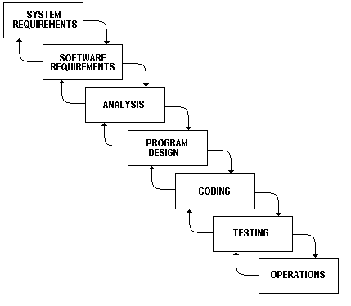

The waterfall model works well for projects that are well understood hut complex, because you can benefit from tackling complexity in an orderly way. It works well when quality requirements dominate cost and schedule requirements. Elimination of midstream changes eliminates a huge and common source of potential errors

**3.1.2 Project Plan:**

|  |  |  |
| --- | --- | --- |
| **System Analysis** | **Duration** | **Resource Requirement** |
| System Design and Documentation | 2 WEEKS | All |
| Actual Development | 2 WEEKS | All |
| Unit Testing | 1 WEEKS | All |
| Integrated of System | 1 WEEKS | All |
| Test case preparation | 2 WEEKS | All |
| System Testing | 2 WEEKS | All |
| Bug Fixing | 1 WEEKS | All |

**3.1.3 Schedule Representation:**

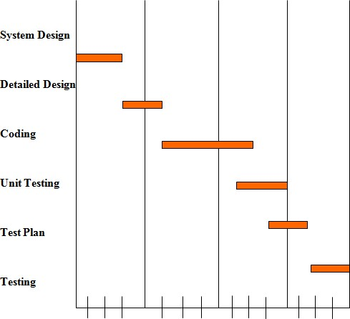

**4**

**Requirements**

**Specification**

**4.1** HARDWARE REQUIREMENTS :

* Intel i3 7th generation And Above
* Minimum 100 GB Hard disk
* Minimum 4 GB RAM
* Mouse, Keyboard
* 4x CR-ROM drive OR USB port

**4.2 SOFTWARE REQUIREMENTS :**

* Ubuntu 18.04LTS, Window 10 ,7
* Xamp web server latest version or wamp server
* PHP 5.6.3
* MySQL 5.5.32
* Microsoft word
* Web Browser :
  + Mozilla Fire Fox & Google Chrome latest version

**5**

**SYSTEM**

**DESIGN**

**5.1 Basic Flow of System**

* **5.1.1 Use Case Diagram**

**User**

View Category

**Admin**

**5.1.2 Data flow diagram:**

Data Flow Diagrams show the flow of data from external entities into the system, and from one process to another within the system. There are four symbols for drawing a DFD:

1. Rectangles representing external entities, which are sources or destinations of data.

2. Ellipses representing processes, which take data as input, validate and process it and output it.

3. Arrows representing the data flows, which can either, be electronic data or physical items.

4. Open-ended rectangles or a Disk symbol representing data stores, including electronic stores such as databases or XML files and physical stores such as filing cabinets or stacks of paper.

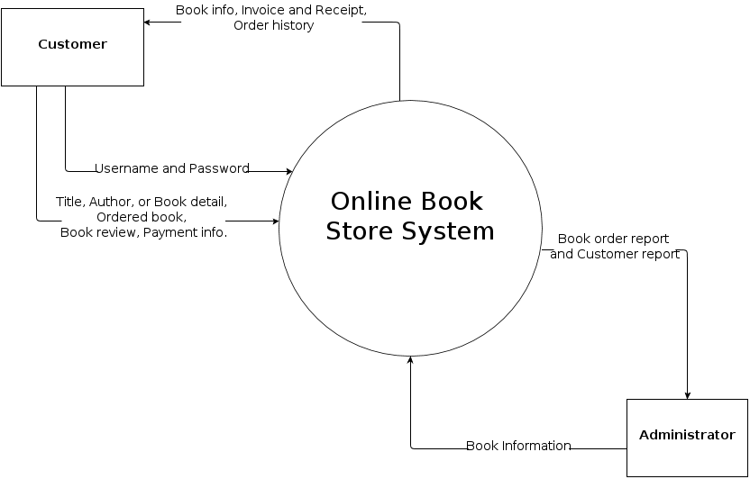

**5.2 System Procedural Design** :

* **5.2.1 ER Diagram**

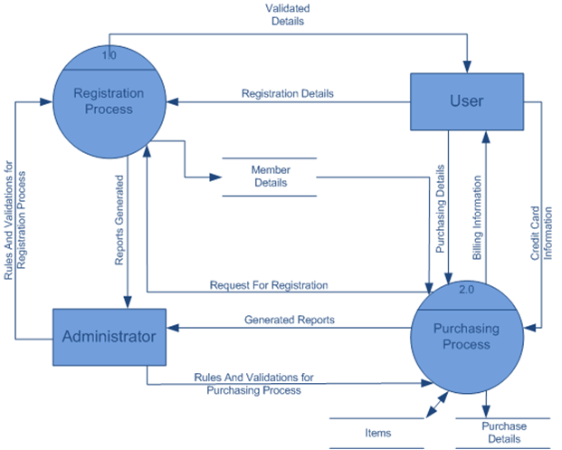

**6**

**IMPLEMENTATION**

* **add_category :**

|  |  |  |  |  |
| --- | --- | --- | --- | --- |
| Table Name | | Add_category | | |
| Description | | This table is used to maintain and store the information related to Book Category. | | |
| Primary Keys | | cat_id | | |
| Key | Field Name | Type | Size | Constraints |
| * | cat_id | Integer | 25 | Primary Key |
|  | Cat_name | Varchar | 40 | Not Null |
|  | Cat_img | Varchar | 60 | Not Null |
|  | Cat_status | Integer | 60 | Not Null |
|  | Cat_time | Varchar | 60 | Not Null |

* **user_register:**

|  |  |  |  |  |
| --- | --- | --- | --- | --- |
| Table Name | | User_register | | |
| Description | | This table is used to maintain and store the information related to user register. | | |
| Primary Keys | | reg_id | | |
| Key | Field Name | Type | Size | Constraints |
| * | reg_id | Integer | 25 | Primary Key |
|  | reg_name | Varchar | 30 | Not Null |
|  | reg_email | Varchar | 30 | Not Null |
|  | reg_password | Integer | 30 | Not Null |
|  | reg_time | Varchar | 50 | Not Null |
|  | Reg_status | Integer | 25 | Not Null |

* **admin_register:**

|  |  |  |  |  |
| --- | --- | --- | --- | --- |
| Table Name | | admin_register | | |
| Description | | This table is used to maintain and store the information related to admin register. | | |
| Primary Keys | | a_reg_id | | |
| Key | Field Name | Type | Size | Constraints |
| * | a_reg_id | Integer | 25 | Primary Key |
|  | a_reg_name | Varchar | 40 | Not Null |
|  | a_reg_email | Varchar | 30 | Not Null |
|  | a_reg_password | Integer | 30 | Not Null |
|  | a_reg_time | Varchar | 60 | Not Null |
|  | a_reg_status | Integer | 40 | Not Null |

* **add_sub_category:**

|  |  |  |  |  |
| --- | --- | --- | --- | --- |
| Table Name | | Add_sub_category | | |
| Description | | This table is used to maintain and store the information related to Book sub-Category. | | |
| Primary Keys | | Sub_cat_id | | |
| Key | Field Name | Type | Size | Constraints |
| * | sub_cat_id | Integer | 60 | Primary Key |
|  | cat_name | Varchar | 60 | Not Null |
|  | sub_cat_name | Varchar | 60 | Not Null |
|  | sub_cat_img | Varchar | 60 | Not Null |
|  | sub_cat_status | Integer | 60 | Not Null |
|  | sub_cat_time | Varchar | 60 | Not Null |

* **add_book:**

|  |  |  |  |  |
| --- | --- | --- | --- | --- |
| Table Name | | add_book | | |
| Description | | This table is used to maintain and store the information related to add book. | | |
| Primary Keys | | book_id | | |
| Key | Field Name | Type | Size | Constraints |
| * | book_id | Integer | 60 | Primary Key |
|  | sub_cat_name | Varchar | 60 | Not Null |
|  | book_name | Varchar | 60 | Not Null |
|  | book_author | Varchar | 60 | Not Null |
|  | book_img | Varchar | 60 | Not Null |
|  | book_pdf | Varchar | 80 | Not Null |
|  | book_desc | Varchar | 80 | Not Null |
|  | book_time | Varchar | 60 | Not Null |
|  | book_status | Integer | 60 | Not Null |

* **book_read_user:**

|  |  |  |  |  |
| --- | --- | --- | --- | --- |
| Table Name | | book_read_user | | |
| Description | | This table is used to maintain and store the information related to Book read user. | | |
| Primary Keys | | reader_id | | |
| Key | Field Name | Type | Size | Constraints |
| * | reader_id | Integer | 60 | Primary Key |
|  | reader_name | Varchar | 60 | Not Null |
|  | reader_book | Varchar | 60 | Not Null |
|  | reader_status | Integer | 60 | Not Null |
|  | reader_time | Varchar | 60 | Not Null |

* **home_biography:**

|  |  |  |  |  |
| --- | --- | --- | --- | --- |
| Table Name | | home_biography | | |
| Description | | This table is used to maintain and store the information related to biography books. | | |
| Primary Keys | | bio_id | | |
| Key | Field Name | Type | Size | Constraints |
| * | bio_id | Integer | 60 | Primary Key |
|  | bio_name | Varchar | 60 | Not Null |
|  | bio_author | Varchar | 60 | Not Null |
|  | bio_img | Varchar | 60 | Not Null |
|  | bio_pdf | Varchar | 60 | Not Null |
|  | bio_desc | Varchar | 60 | Not Null |
|  | bio_time | Varchar | 60 | Not Null |
|  | bio_status | Integer | 60 | Not Null |

* **DataBase Structure (image)**

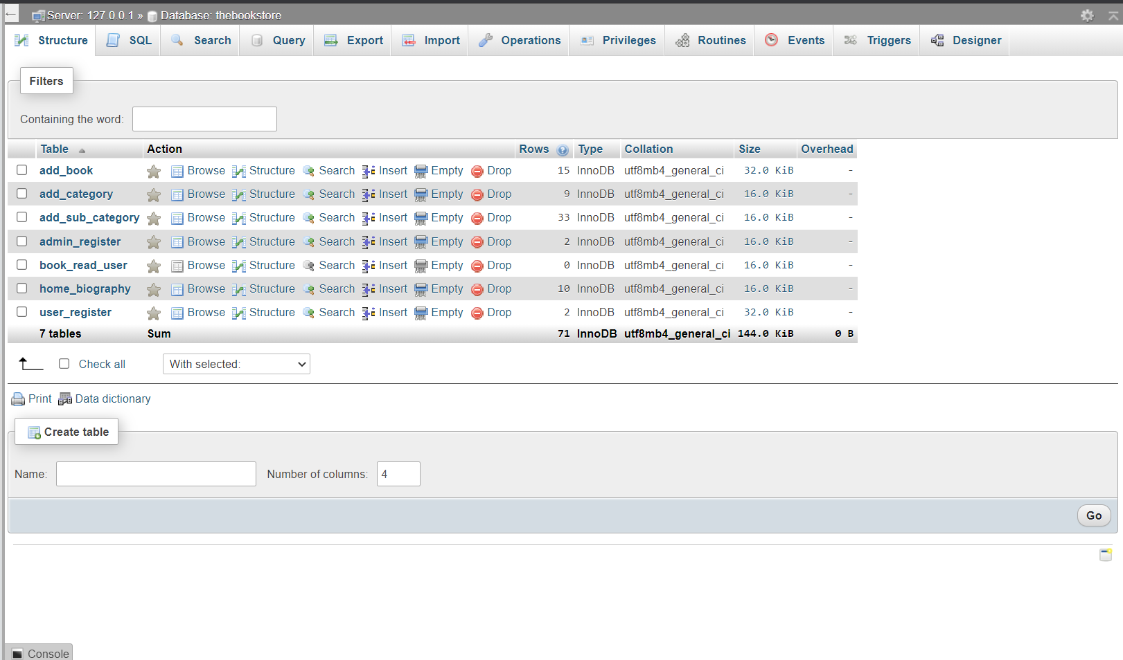

* **Front-End Website Layout:**
* **Register page:**

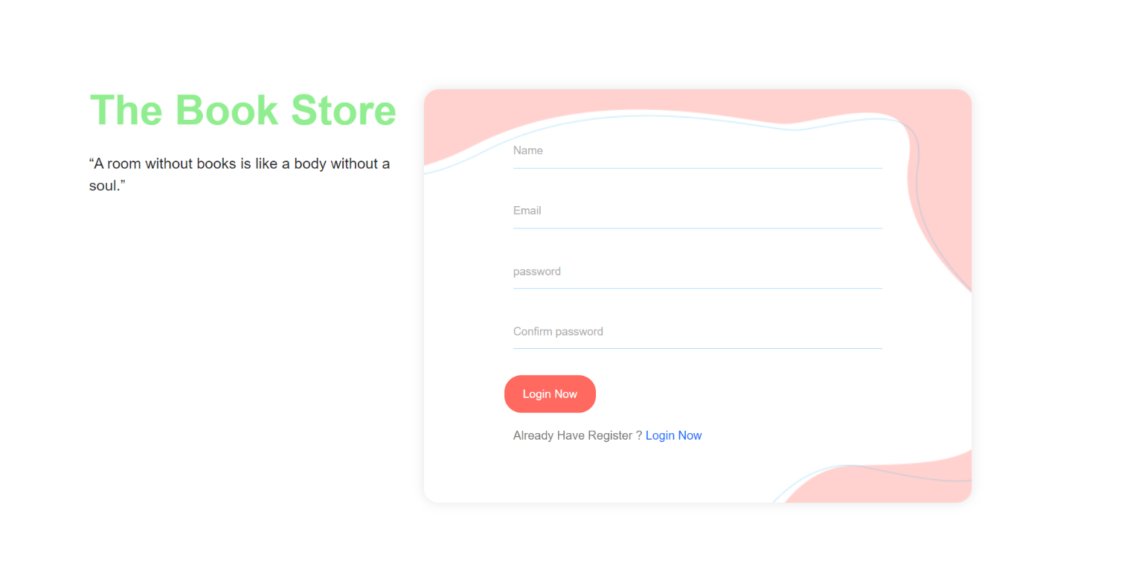

* **Login page:**

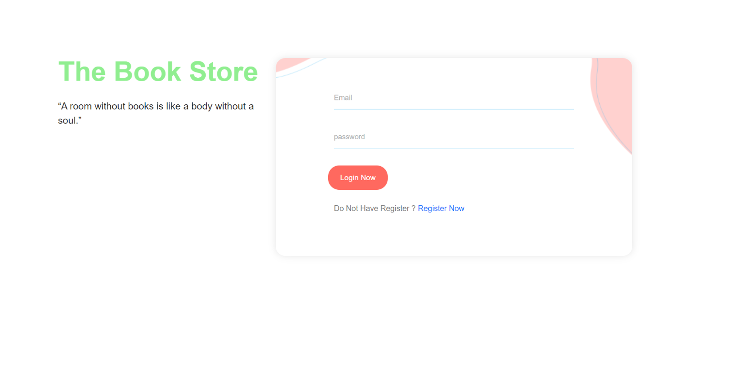

* **Banner Page (Landing Page)**



* **Home page:**

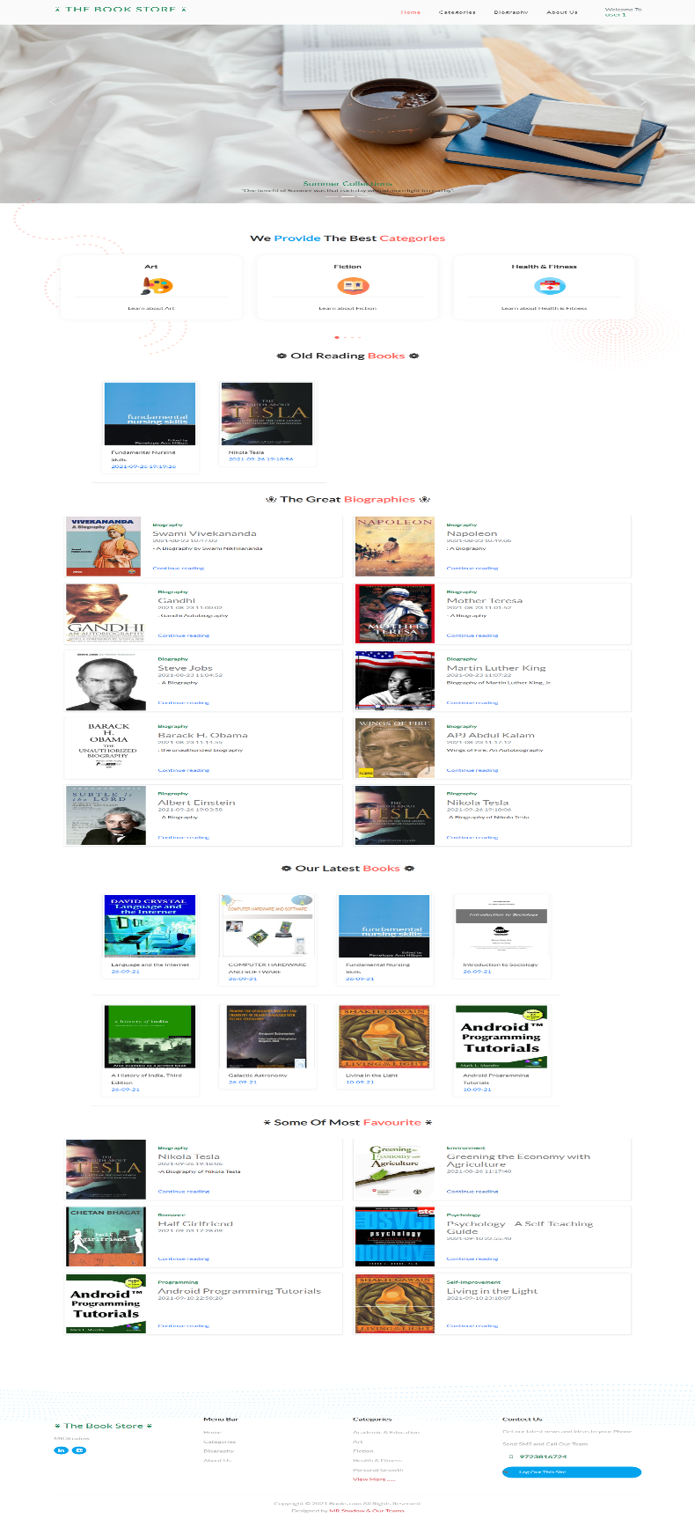

* **Category page:**

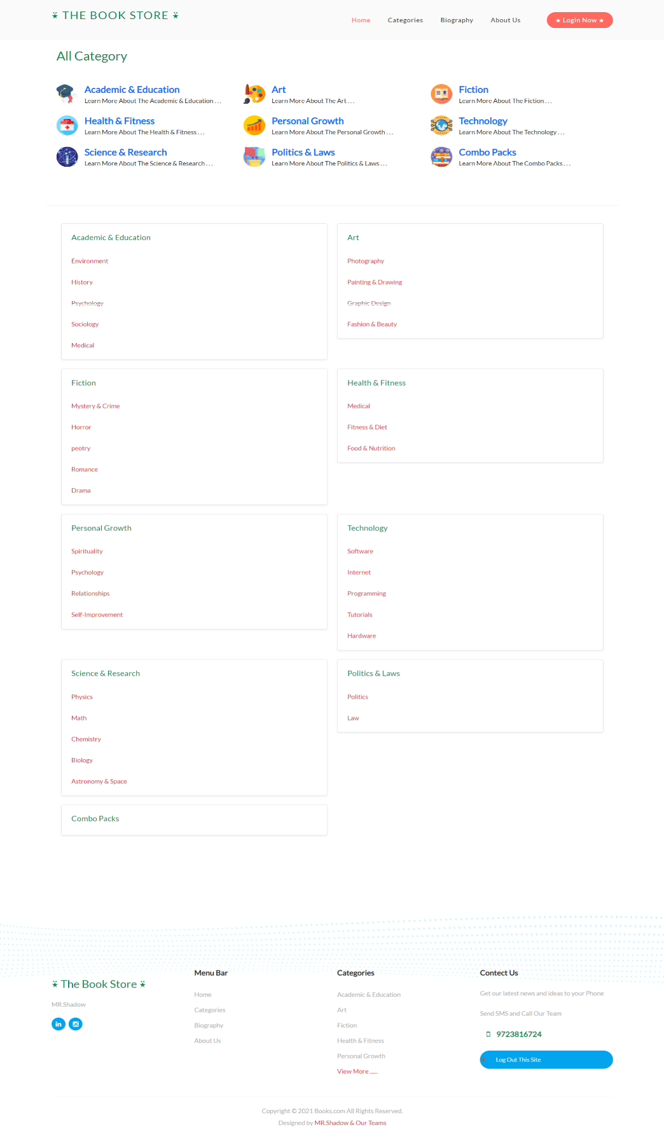

* **Book page:**

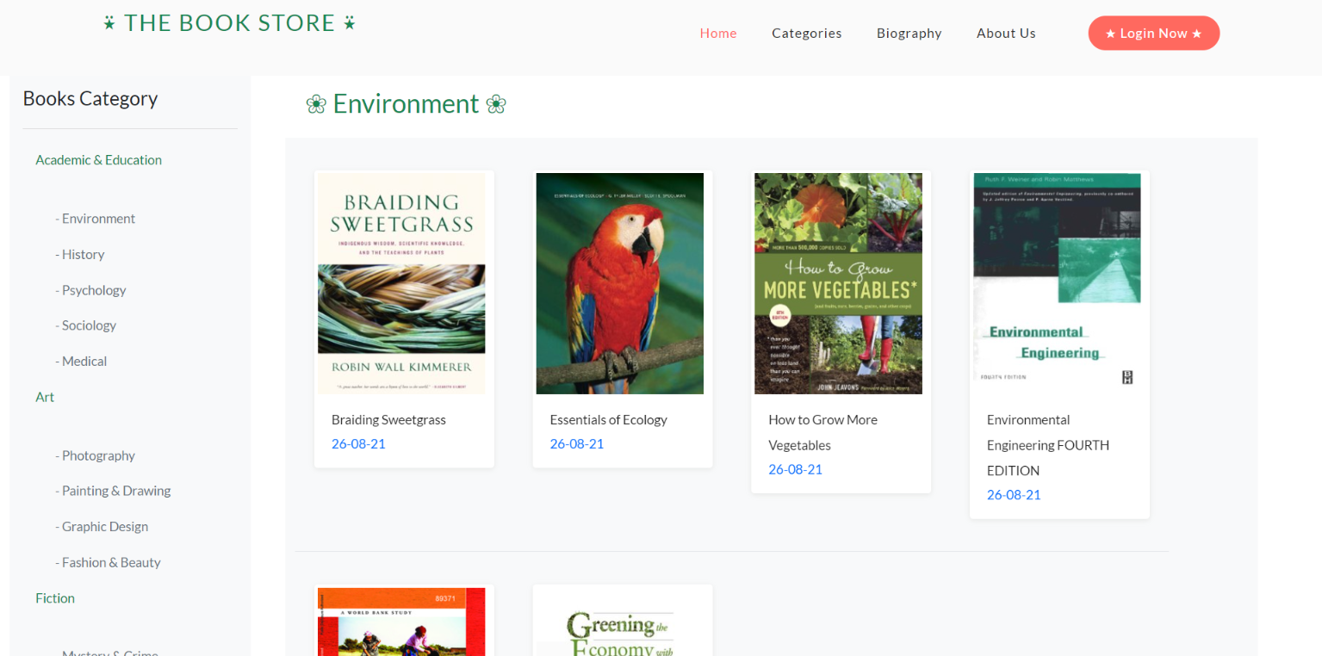

* **Book Detail Page:**

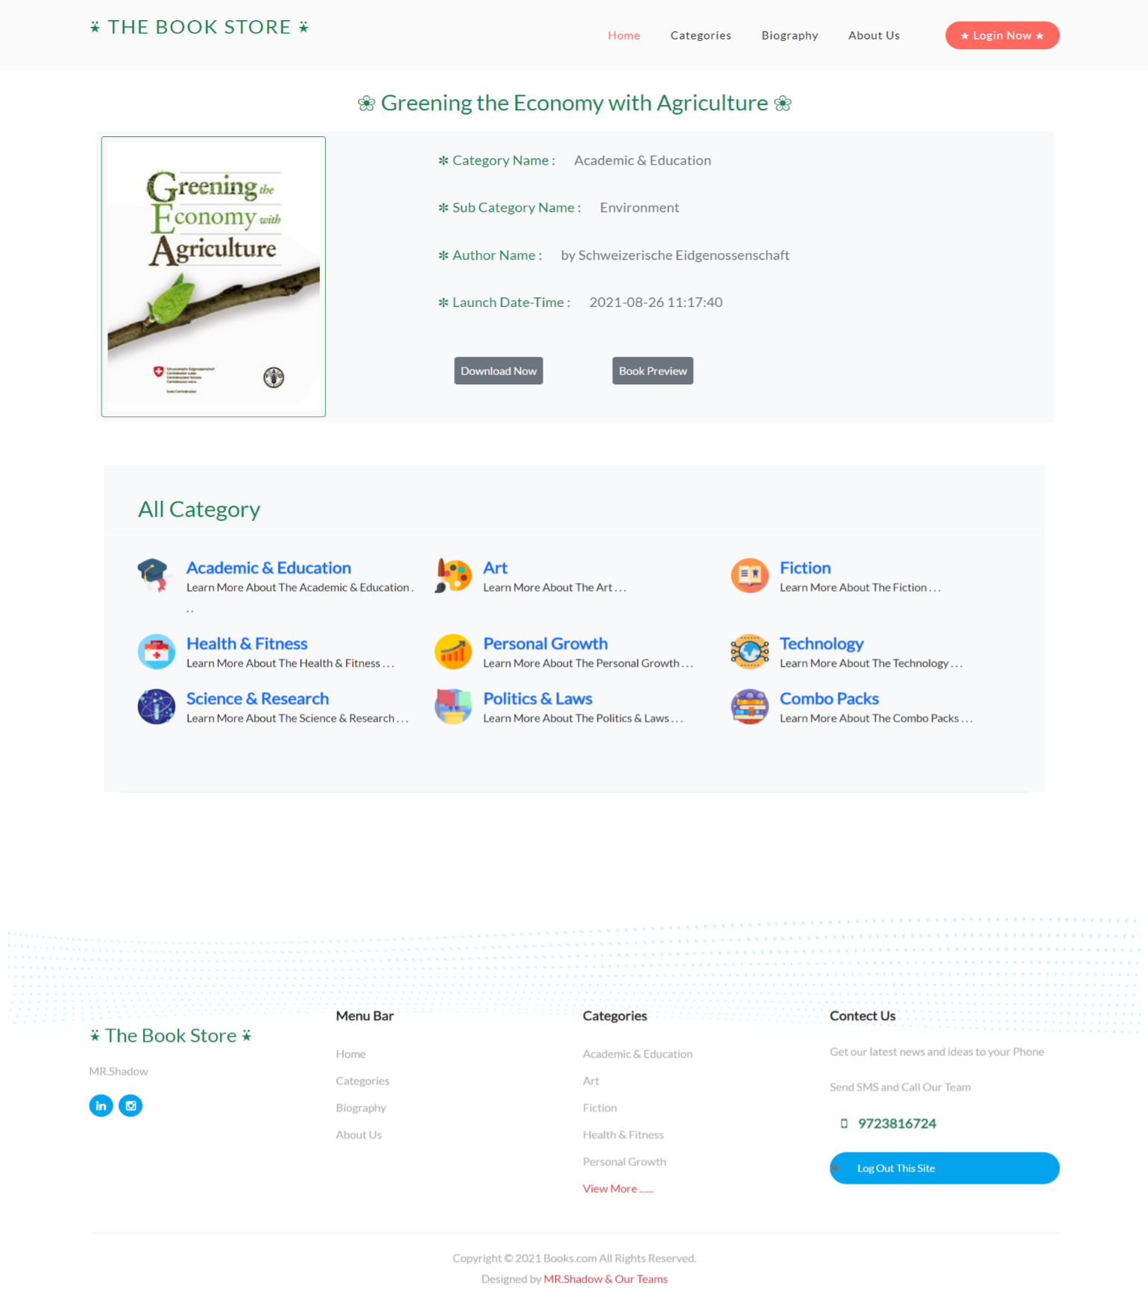

* **About page:**

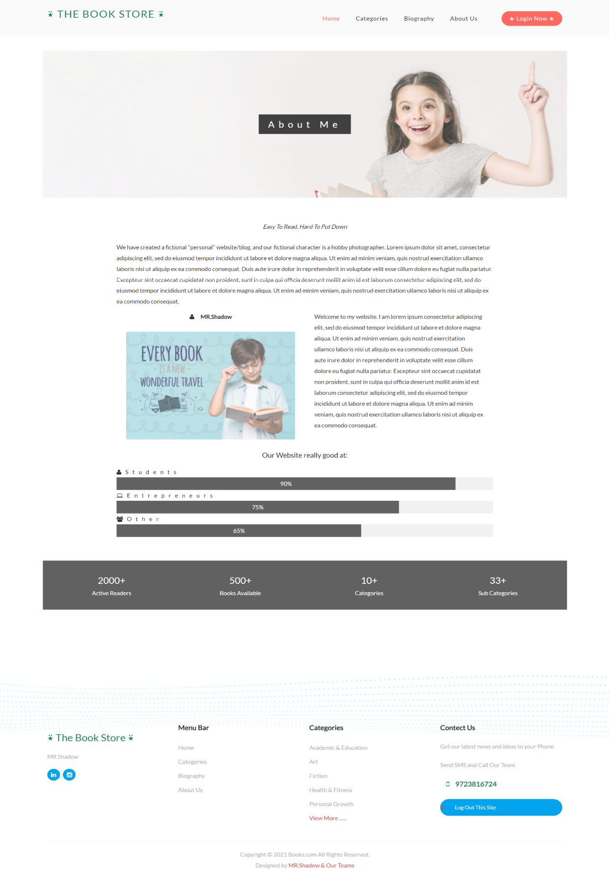

* **Admin Side :**
* **Register Page:**

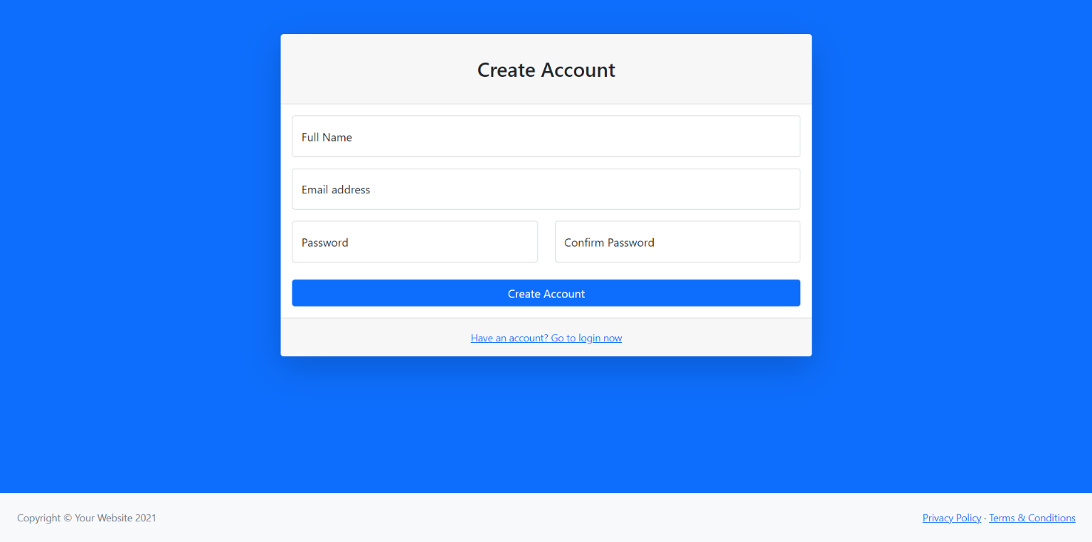

* **Login page :**

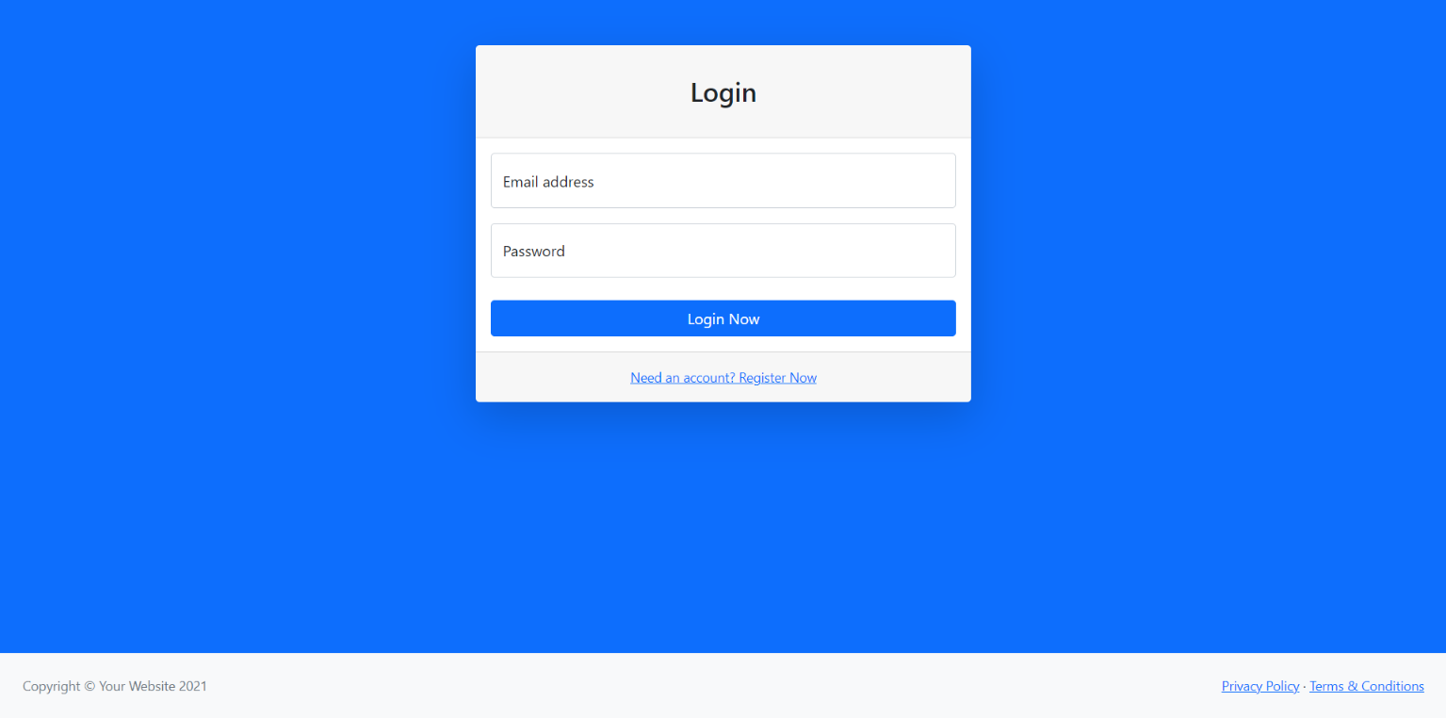

* **Home Page:**

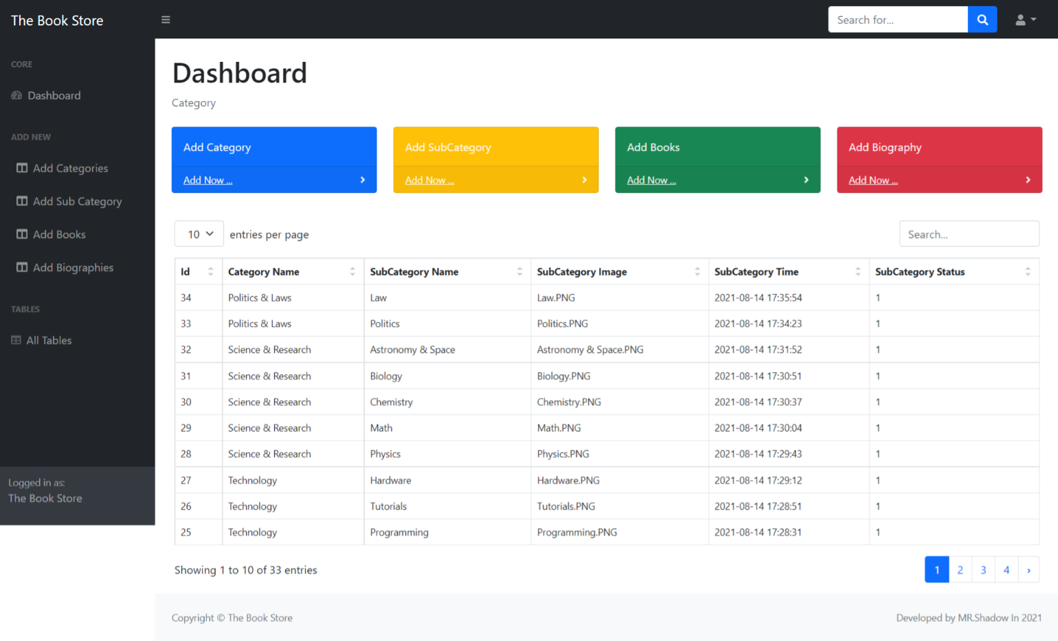

* **Add category Page:**

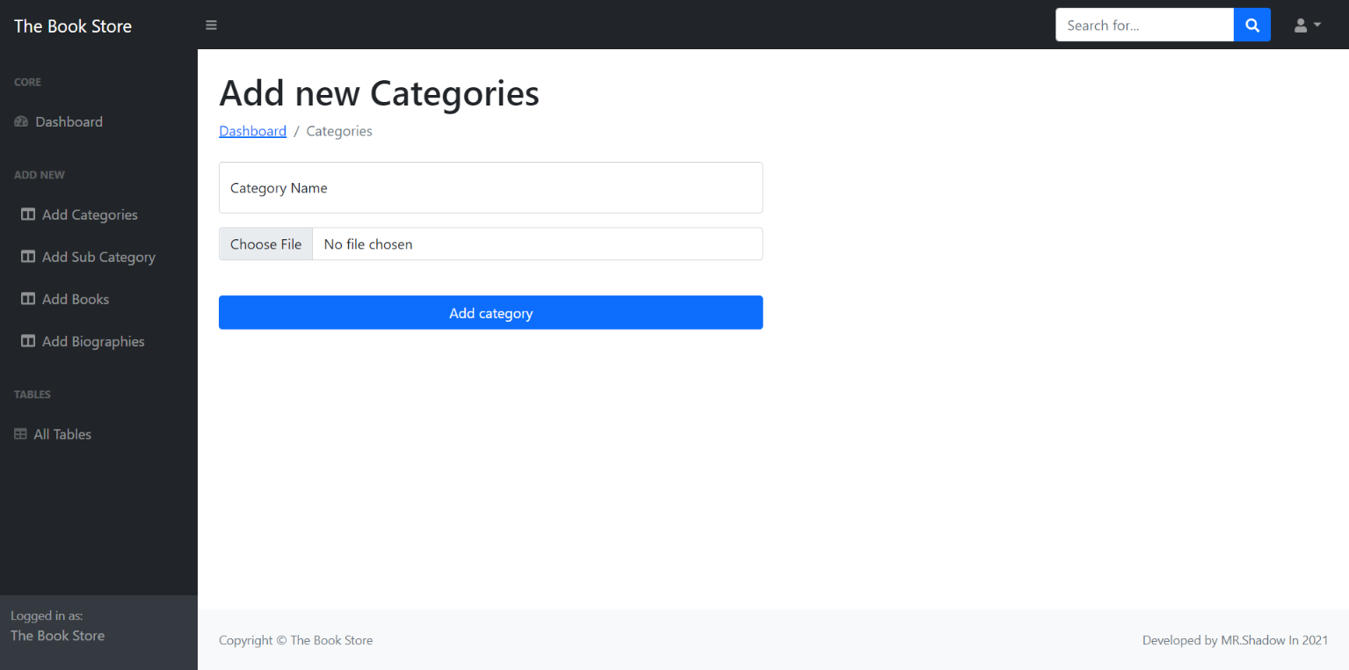

* **Add Subcategory Page:**

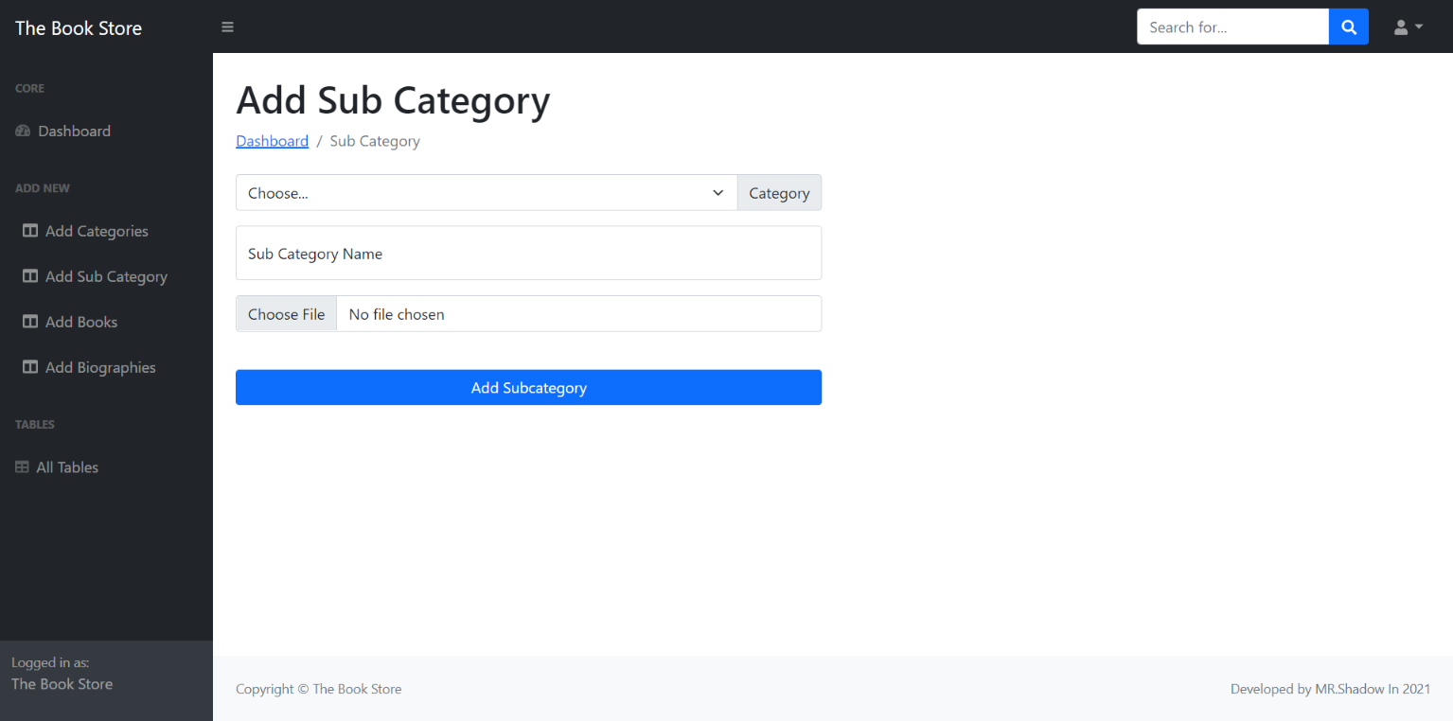

* **Add Book Page:**

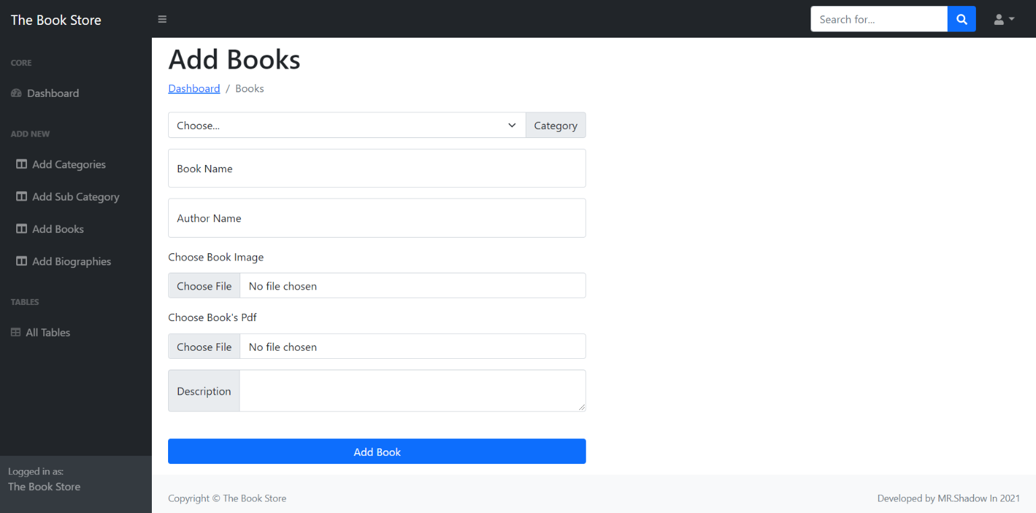

* **Add Biography Page:**

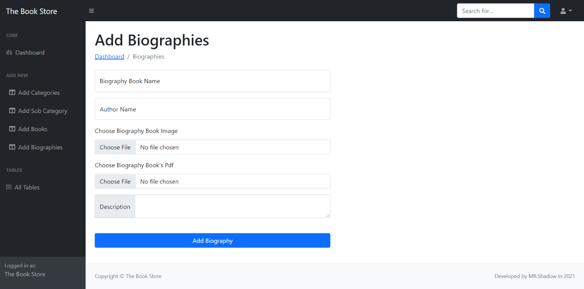

* **Update Category & Subcategory :**

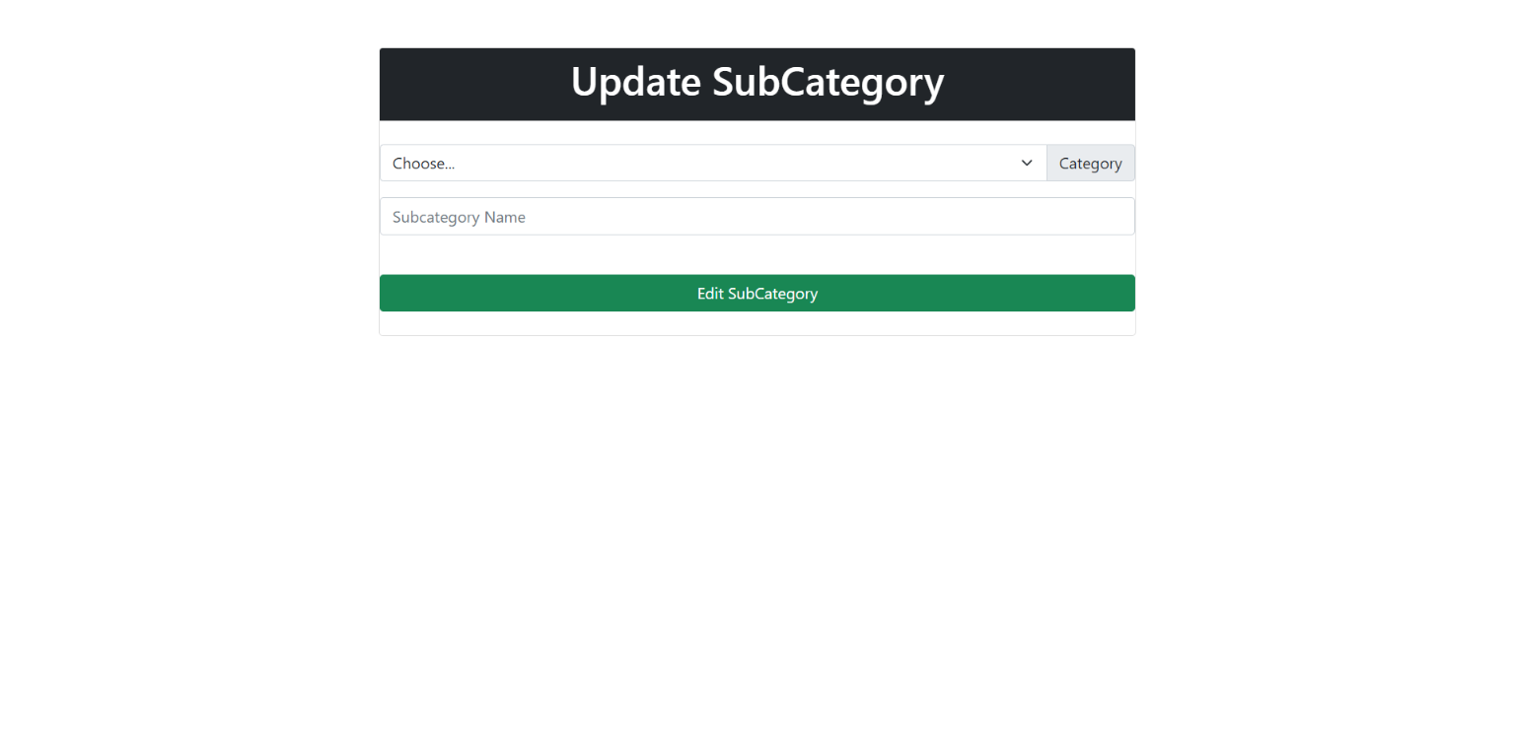

* **Show Tables Page:**

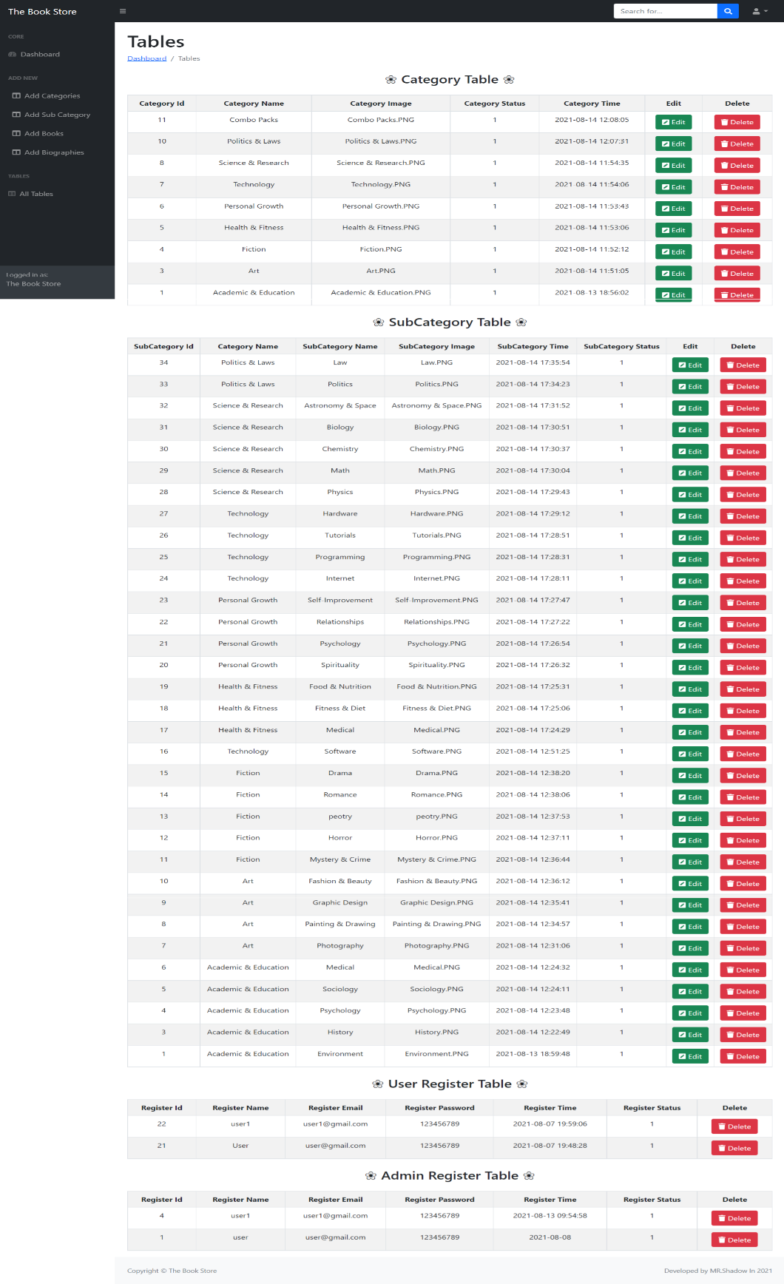

**7**

**Testing**

**7.1 TESTING**

*Testing*is one of the important steps in system development. Software Testing also provides an objective, independent view of the software to allow the business to appreciate and understand the risks at implementation of the software. Test techniques include, but are not limited to, the process of executing a program or application with the intent of finding [software bugs.](http://en.wikipedia.org/wiki/Software_bugs)

Software Testing can also be stated as the process of validating and verifying that a software program/application/product:

1. Meets the business and technical requirements that guided its design and development;
2. Works as expected; and
3. Can be implemented with the same characteristics.

Software Testing, depending on the testing method employed can be implemented at any time in the development process. However, most of the test effort occurs after the requirements have been defined and the coding process has been completed. As such, the methodology of the test is governed by the Software Development methodology adopted.

**7.2 TESTING LEVELS**

Tests are frequently grouped by where they are added in the software development

process, or by the level of specificity of the test.

* + 1. **Unit Testing**

*Unit Testing* refers to tests that verify the functionality of a specific section of code, usually at the function level. In an object-oriented environment, this is usually at the class level, and the minimal unit tests include the constructors and destructors.

These types of tests are usually written by developers as they work on code (white-box style), to ensure that the specific function is working as expected. One function might have multiple tests, to catch corner cases or other branches in the code. Unit testing alone cannot verify the functionality of a piece of software, but rather is used to assure that the building blocks the software uses work independently of each other. Unit testing is also called *Component Testing.*

* + 1. **Integration Testing**

*Integration Testing* is any type of software testing that seeks to verify the interfaces between components against a software design. Software components may be integrated in an iterative way or all together ("big bang"). Normally the former is considered a better practice since it allows interface issues to be localized more quickly and fixed.

[Integration Testing w](http://en.wikipedia.org/wiki/Integration_testing)orks to expose defects in the interfaces and interaction between integrated components (modules). Progressively larger groups of tested software components corresponding to elements of the architectural design are integrated and tested until the software works as a system.

* + 1. **System Testing**

[System Testing](http://en.wikipedia.org/wiki/System_testing) tests a completely integrated system to verify that it meets its requirements.

* 1. **TYPES OF TESTING**

**7.3.1 FUNCTIONAL TESTING**

It is an approach to testing where the tests are derived from the program or component specification. The system is a black box whose behavior can only be determined by studying its inputs and the related outputs.

* + 1. **STRUCTURAL TESTING**

Structural testing is an approach to testing where the tests are derived from knowledge of the software‘s structure and implementation. This approach is sometimes called ‗white-box testing‘ to distinguish from black –box testing.

**8.**

**FUTURE WORK**

* We have done analysis of this entire system till now, and in future we will develop this system as per our analysis.

* In future this Website will became very user-friendly and UI design will very effective.

* We will covert this web-site into app management so that any user can access our app anywhere through their mobiles .
* Payment , home delivery and Bank facilities will be available .

**9**

**CONCLUSION**

I have developed *“The E-Book Store” website* in Readers to overcome the difficulties in managing the existing manual systems. The website has been designed effectively keeping in mind, the possible future enhancement and additional functionality; it has been designed to run in an efficient way.

The website is designed to be very user-friendly and interactive manner so that the user cannot find any difficulty while browsing the website. Thereby the proposed website, which is an economically, technically and operationally feasible system has overcome the deficiency that was present in the manual system.

**10**

**REFERENCES**

* This project was impossible to be a success without the support and help from the experience guide , the books and mainly the internet really prove it for us the “Information Highway”. Everything was really easy to find out on the internet.
* **WEBSITE :**
* [www.w3school.com](http://www.w3school.com/)
* <https://www.snapdeal.com/products/books>
* <https://www.storyshares.org/books/home>
* <https://www.amazon.in/Books/b?ie=UTF8&node=976389031>
* <https://stackoverflow.com/>

#### Last But Not List :

1. Github ( Source Code) Link :

https://github.com/Shadow-Bhai/The_E-Book.git

2. C Panel Link :

3. Live Website :

4. Admin Panel :